The importance of researching the market and creating a strong brand

When I started Cake Lingerie 5 years ago, the idea for beautiful maternity/nursing lingerie was conceived out of a personal need. I had no expertise or experience in the lingerie industry or rag trade for that matter.

I knew my idea was a good one, especially as I researched existing product globally, whilst speaking with women who also found maternity lingerie to be unflattering and unappealing.
It was clear there was a gap in the market. An untapped niche that I couldn’t ignore!

Mainstream lingerie was marketed beautifully, however, maternity lingerie was ignored. It was my intention to deliver a brand that looked and was marketed like mainstream lingerie, whilst delivering the essential comforts, shape and support.

Every touch point from the brand name, tags, fabric selections, colours, photography, gift boxes, look books, logo, website, were carefully designed to create to be impactful & memorable. A consistent brand message, both visually and verbally was key to establishing the Cake Lingerie brand.

BRAND NAME

This was very difficult and was probably one of the hardest decisions to make.

I wanted the brand to be fun, playful and unforgettable. Most maternity brands referred to pregnancy. I did not want this. I wanted it to celebrate the woman not the experience she was going through.

The brand name ‘Cake Lingerie’ finally came about after weeks of brainstorming. A name that was associated with decadence, happiness, indulgence and worked particularly well with the ‘Yummy Mummy’, which was just catching on at the time.

Once I had the brand name the colour palette, logo, and product names all fell into place.

ABOUT TRACEY
A creative arts teacher, I never dreamt of having my own business let alone creating one from my personal need.
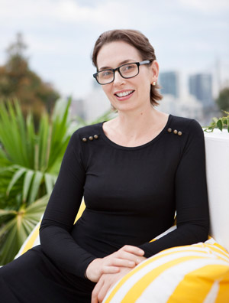
I was 32 at the time, based in London and about to have my first child. Used to having nice things and wearing quality, fashionable clothing, my search began for maternity & nursing lingerie that was feminine, stylish, comfortable, functional and fit correctly. A non-event to say the least. It did not exist!
THE IDEA
My existing bras and nightwear no longer fit and like most women, I wanted to buy some underwear, similar to what I was used to wearing before I was pregnant. Why did I have to compromise? I was young, glowing and pregnant and loving my curves.
I searched high and low, on the web, in the high street stores, called my friends in other countries. It became clearly evident that the product I was looking for was unavailable. It saddened me and made me more conscious about my body. Other women I spoke to had the same complaint.
SETTING UP
I had no idea about the bra industry, but I did know there was a market for fashionable, comfortable but yet functional maternity bras. Having contacted and discussed the idea, with tons of women from all walks of life, I was convinced.
Learning about the product detail was key, which forced me to Fashion School. Whilst managing my home and young child, I spent every spare minute researching manufacturing options. Eighteen months & 7 manufacturers later I finally found one who was capable of meeting with my stringent product & quality expectation.
SATISFACTION
I created Cake Lingerie to empower pregnant and breastfeeding women! To make woman look and feel great during this extraordinary period in our lives.
Tracey x

http://www.cakelingerie.com/
http://www.facebook.com/cakelingerie

